MOVIE RENTAL ANALYSIS

**Overview:**

The movie rental analytics project is a comprehensive data analysis initiative aiming to revolutionize the movie rental industry. By leveraging advanced analytics techniques, this project seeks to uncover invaluable insights from rental data. It delves into customer preferences, rental patterns, and operational efficiency, intending to optimize inventory selection, pricing strategies, and operational processes. Ultimately, the project endeavors to enhance customer satisfaction, streamline operations, maximize revenue, and position the movie rental service at the forefront of the market by embracing a data-driven and customer-centric approach.

**Objective:**

The primary objective of a movie rental analytics project is to harness data-driven insights for optimizing every facet of the movie rental business. This involves scrutinizing customer behaviors, preferences, and viewing habits to tailor inventory, pricing, and marketing strategies. By segmenting customers and understanding their unique needs, the project aims to enhance customer satisfaction, reduce operational inefficiencies, and boost revenue by offering a personalized and seamless rental experience. Furthermore, predictive analysis allows for strategic planning, ensuring the availability of the right movies at the right time to meet demand, ultimately creating a profitable and customer-centric movie rental service.

In essence, the movie rental analytics project strives to transform raw rental data into actionable intelligence that drives informed decision-making. This encompasses everything from fine-tuning the inventory based on customer tastes and behaviors to optimizing pricing models, ultimately fostering a more efficient and satisfying movie rental service for both customers and the business alike.

**Significance:**

The movie rental analytics project holds multifaceted significance that can transform the movie rental industry in several ways:

1. *Informed Decision-Making:

- By analyzing rental data, businesses can make informed decisions regarding inventory selection, pricing strategies, and marketing campaigns. This ensures that the offerings align with customer preferences and market demand, leading to better customer engagement and increased rentals.

2. *Optimized Inventory Management:

- Understanding customer preferences helps in curating an inventory that matches popular genres, actors, or directors. This optimization reduces the risk of overstocking or understocking, enhancing cost-efficiency and maximizing revenue by having in-demand movies readily available.

3. *Dynamic Pricing Strategies:

- Analyzing rental patterns and customer behavior allows for the implementation of dynamic pricing models. Businesses can adjust prices based on factors like movie popularity, time of rental, or customer segments, optimizing revenue and attracting a wider range of customers.

4. *Enhanced Customer Experience:

- By analyzing customer data, businesses can offer personalized recommendations, improving the overall user experience. Tailoring services to individual preferences fosters customer loyalty, increases customer satisfaction, and encourages repeat business.

5. *Fraud Detection and Cost Efficiency:

- Utilizing analytics to detect fraudulent activities in rentals safeguards the business from potential financial losses. Additionally, the project can identify areas of unnecessary costs, promoting cost-efficiency and boosting overall profitability.

6. *Predictive Analysis and Future Planning:

- Predictive analytics can forecast future rental trends, enabling businesses to plan ahead and make proactive decisions. This ensures timely acquisition of popular titles, preventing stockouts and maximizing rental potential.

7. *Market Competitiveness and Innovation:

- Analyzing the market and consumer trends helps businesses stay competitive. By adapting strategies based on data insights, movie rental services can continuously innovate, meet evolving customer needs, and remain relevant in a dynamic and competitive industry.

8. *Sustainable Growth and Industry Evolution:

- The project's insights into customer preferences and market dynamics contribute to the sustainable growth of the movie rental industry. By adapting to changing trends and embracing technological advancements, the industry can evolve to meet modern consumer expectations.

In summary, the movie rental analytics project significantly impacts the industry by fostering data-driven decision-making, improving operational efficiency, enhancing customer satisfaction, ensuring business sustainability, and driving innovation for long-term growth and competitiveness.

**Data dictionary:**

A data dictionary for a movie rental analytics project typically defines and describes the various data elements or attributes used in the project. Here's a simplified example of a data dictionary:

1. MovieID (Numeric):

- Unique identifier for each movie in the rental database.

2. Title (Text):

- The title of the movie.

3. Genre (Text):

- The genre or category of the movie (e.g., Action, Comedy, Drama).

4. Director (Text):

- The director of the movie.

5. Actor1, Actor2, Actor3 (Text):

- Primary and supporting actors in the movie.

6. ReleaseDate (Date):

- The date the movie was released.

7. RentalDate (Date and Time):

- Date and time the movie was rented.

8. ReturnDate (Date and Time):

- Date and time the movie was returned.

9. CustomerID (Numeric):

- Unique identifier for each customer.

10. Age (Numeric):

- Age of the customer.

11. Gender (Text):

- Gender of the customer.

12. RentalPrice (Numeric):

- The price the customer paid to rent the movie.

13. Rating (Numeric)

- The movie rating (e.g., PG-13, R, etc.).

14. ReviewScore (Numeric):

- Customer's review score for the movie.

15. Location (Text):

- Customer's location or region.

16. Promotions (Boolean)

- Indicates whether a promotional offer was used during rental.

|  |  |  |
| --- | --- | --- |
| Table Name | Important Columns | Significance |
| Rental- Transaction table containing information about all the rental transaction | Rental id | Unique identifier for each movie in the rental database |
| Amount | The price the customer paid to rent/buy the movie |
| Payment date | Date of payment made |
| Customer- This lookup table contains information about the customers | ID | Unique identifier for each customer |
| Name | Name of the customer |
| City | City of residence of the customer |
| Country | Country of residence of the customer |
| SID | Store ID associated with the customer during purchase |
| Inventory- This lookup table contains information about the inventory maintained in the stores | Inventory Id | Unique ID associated with each inventory |
| Category/Genre | The genre or category of the movie (e.g., Action, Comedy, Drama). |
| Film id | Unique Id of the film present in the inventory |
| Store Id | Unique Id of the store |
| Film- This is lookup table about films containing information about film id, title, duration etc. | Film Id | Unique ID associated with the movie |
| Title | Title of the movie |
| Rental duration | Indicates if the rental was returned late |
| Rental rate | Price of the rental movie |
| Rating | Rating of the movie |
| Film Actor- This is a transaction table for the film actors and the films they appeared in. | Actor ID | ID associated with the actor |
| Movie ID | ID associated with the movie |
| Actor Info – This is a lookup table containing information about the films | Actor ID | Unique ID of the primary actor in the movie |
| Staff- This is lookup table containing information about the staff | Staff ID | Unique ID of the staff |
| Name | Name of the staff |
| Address- This is a lookup table about the address | Address | Address of the staff |
|  |  |  |

This data dictionary provides a clear understanding of the types of data and their attributes that would be collected, stored, and analyzed in a movie rental analytics project. It's essential for standardizing the understanding and use of data within the project team.

**ER Diagram:**

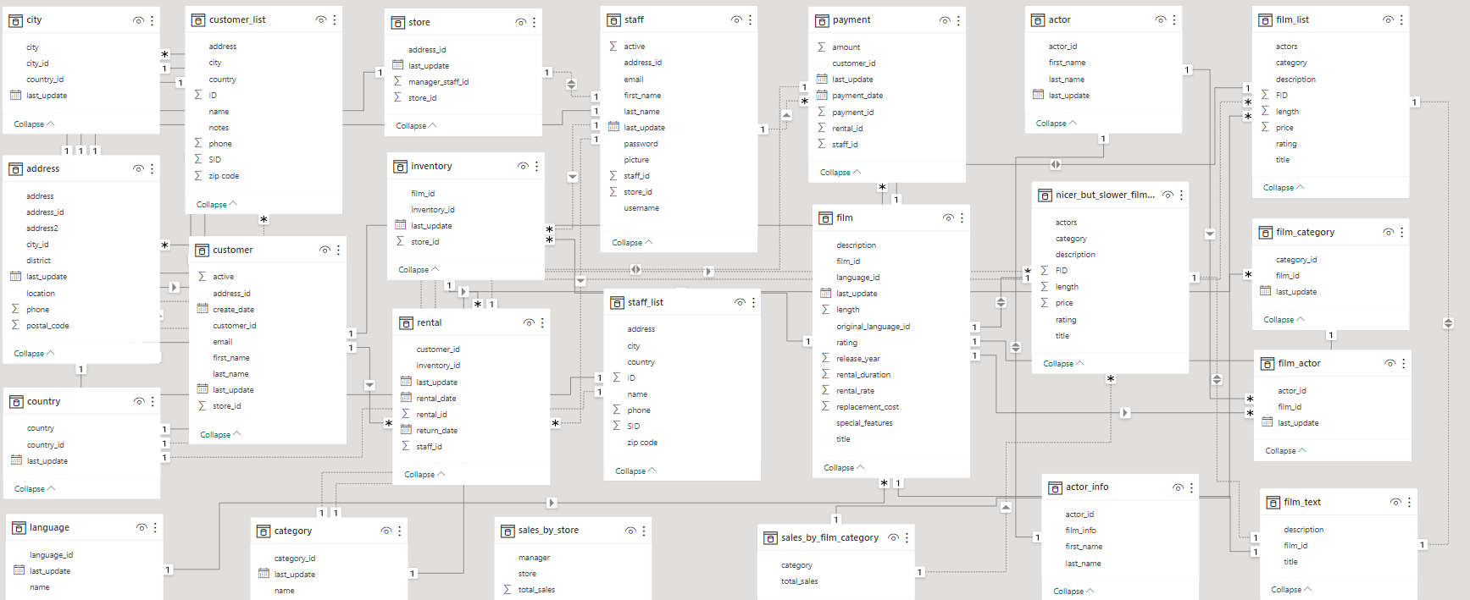

**Problem statements with solution and insights:**

Exploratory Data Analysis (EDA) comparing purchasing patterns of new customers versus repeat customers involves a detailed examination of their buying behaviors within a movie rental service. By analyzing the data on customer purchases, we can identify trends and differences in spending habits. Descriptive statistics and visualizations provide insights into the distribution of purchase amounts for both groups, allowing for a comparison of their purchasing frequencies and preferences. Statistical tests help determine if there are significant variations in purchase amounts. Additionally, exploring customer lifetime value and product preferences sheds light on the potential profitability and customer engagement strategies, ultimately informing decision-making to enhance the overall movie rental experience for both new and repeat customers.



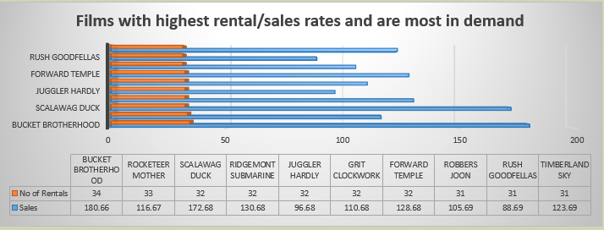

Analyzing movies with high rental rates and high demand involves a thorough examination of various aspects influencing their popularity. By scrutinizing rental data, customer reviews, and ratings, we can identify movies commanding higher rental rates. Understanding the factors that contribute to their demand, such as genre preferences, promotional strategies, release dates, and positive customer feedback, allows for tailored marketing and inventory decisions. Comparing these movies with lower rental counterparts helps discern unique features that attract customers. Demographic analysis provides insights into target audience preferences, enabling the customization of recommendations. Additionally, recognizing movies with consistent repeat rentals helps devise strategies to maintain customer loyalty, ensuring continued success for these high-demand titles within the movie rental service. Ultimately, this analysis facilitates data-driven decision-making to optimize business strategies and enhance customer satisfaction.

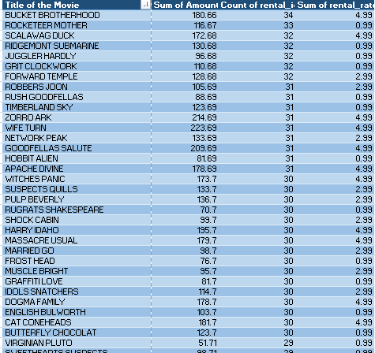

And regarding the correlation between the staff performance and customer satisfaction, there is no enough information to measure the customer satisfaction and the staff service to rate or value it to process further. However, as an alternative we can get basic insight through data such as sales and rental counts of the customers.

Seasonal trends in customer behavior across different locations:

Seasonal behavior in movie rental patterns varies based on different locations due to diverse climate conditions, cultural events, and regional preferences. In colder regions, there's a notable increase in movie rentals during fall and winter when people tend to stay indoors. Conversely, warmer regions experience higher rental activity in summer when escaping the heat becomes a priority. Major holidays like Christmas and New Year's prompt a surge in rentals worldwide, as families and friends seek indoor entertainment during festive seasons. Cultural and regional events can also influence movie rentals, creating fluctuations tied to specific festivities or local celebrations. Additionally, school holidays, tourist seasons, and even local preferences, such as sports events or premieres, impact rental trends in distinct locations. Adapting movie offerings and marketing strategies to align with these seasonal behaviors ensures a more tailored and successful approach for movie rental businesses across various regions.

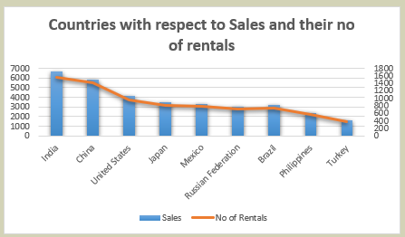

Are certain language films more popular among specific customer segments?

Absolutely, the language of films significantly influences their popularity among specific customer demographics. But with checking on the given datasets there is no suck information of other language movies which is fully provided with English language movies which are more prominent in all parts of the world. So in this case that cannot be predicted or analyzed in detail.

Regarding the customer loyalty impact sales revenue over time:

Certainly! Customer loyalty directly impacts a business's revenue by driving repeat purchases, increasing transaction value, reducing marketing costs, and inspiring referrals. Loyal customers also have a higher Customer Lifetime Value (CLV) and often become brand advocates, attracting new customers through word-of-mouth. This culminates in a steady revenue stream and sets the stage for sustained business growth.

But in the given data there is no such in detail references or details to showcase for a better understanding. However, there is no actual insight but we can come to a conclusion with respect to the sales made by the repeated customers which means that they are loyal and satisfied with the service provided.

There are films popular in certain locations as shown below:

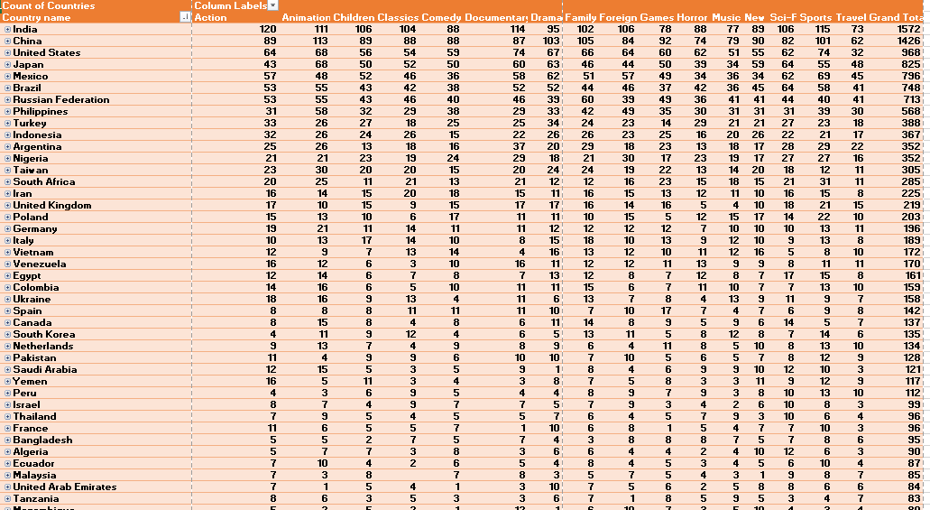

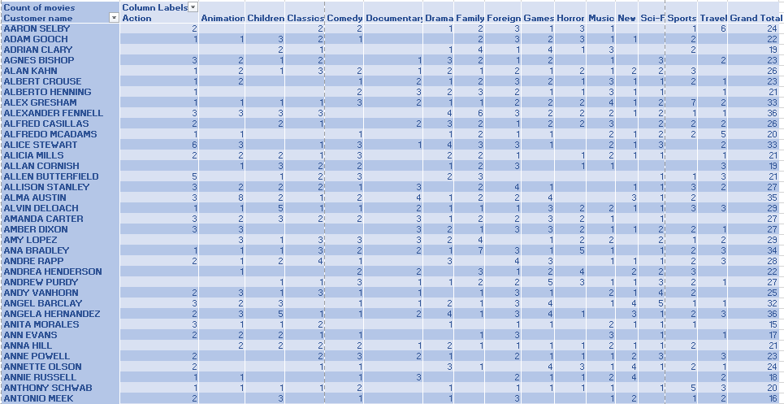

How does the availability and knowledge of staff affect customer ratings?

Upon checking there is no such information regarding the customer rating and knowledgeable insights, that question cannot be answered with excellence but as an alternative we can access a basic insight using the rating category that they provide for the movie to enhance the customer experience and understand the interest of the customer with respect to the movie.

And with regards to it, movies with PG-13 rating performs well in aspects of sales/rentals.

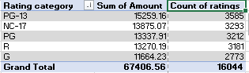

Regarding the proximity of stores to customer’s impact rental frequency, in general the proximity of stores to customers significantly impacts rental frequency. When stores are conveniently located near customers' homes or workplaces, it enhances accessibility and encourages more frequent visits for movie rentals. Shorter travel distances and ease of reaching the store prompt customers to rent movies more often, positively affecting rental frequency. Conversely, when stores are farther away, customers may opt for less frequent rentals due to the inconvenience and time involved in traveling to and from the store. Therefore, strategic store placement to ensure proximity to the customer base is a crucial factor in promoting higher rental frequency.

But when checked with the provided datasets we can confirm and come to a conclusion that there are some stores which has maximum count of sales/rentals which can also be due to many factors like population, age grade etc. But as a result these stores perform well with sales which is the primary need for a successful store.

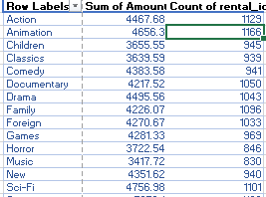

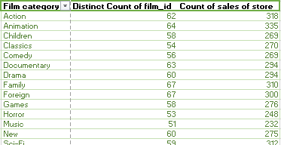

Customer Demographics and preferences:

Understanding customer demographics involves analyzing age, gender, income, education, location, and family status to grasp the composition of the customer base. On the other hand, preferences encompass individual inclinations and behaviors regarding product features, pricing, brand loyalty, and purchase habits. Both aspects are crucial for tailoring products, services, and marketing strategies to meet specific customer needs. Demographics help in identifying target markets and shaping pricing strategies, while preferences guide product customization and marketing campaigns. By comprehending both demographics and preferences, businesses can make informed decisions and enhance customer satisfaction effectively as shown below:

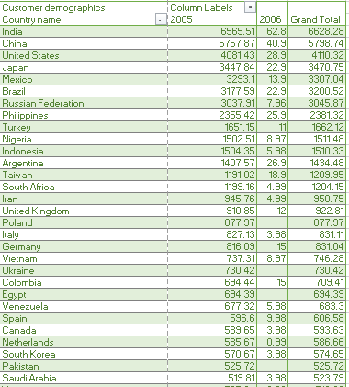

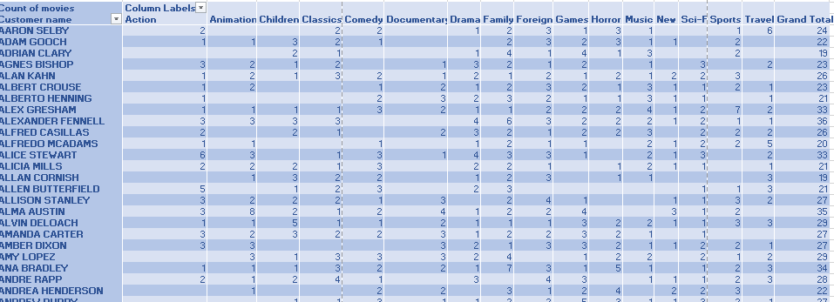

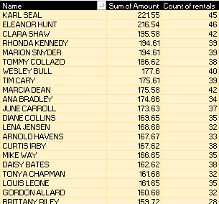

**Impact on availability of inventory with customer satisfaction to repeat business:**

The availability of inventory in a business directly impacts customer satisfaction and repeat business. When a business maintains a diverse and well-stocked inventory, customers are more likely to find what they're looking for, leading to higher satisfaction levels. Conversely, if inventory is limited or frequently out of stock, it can frustrate customers, potentially driving them to competitors.

Adequate inventory availability also fosters repeat business. Customers who consistently find their desired products in stock are more likely to return to the same business. They perceive the business as reliable and are more inclined to develop loyalty and make repeat purchases. On the other hand, insufficient inventory can deter repeat business, as customers may seek alternative options that consistently meet their needs.

Overall, maintaining a balance between inventory availability and customer satisfaction is crucial for building customer loyalty, encouraging repeat business, and ensuring the long-term success of the business. Effective inventory management strategies that align with customer demand and preferences play a key role in achieving this balance.

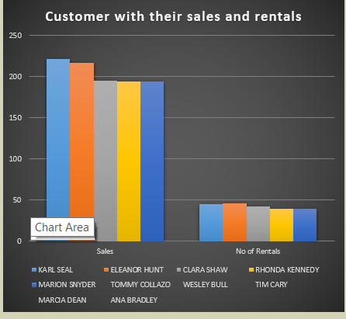

There is also importance and analysis based on hourly sales/rentals happened as shown in the below analysis:

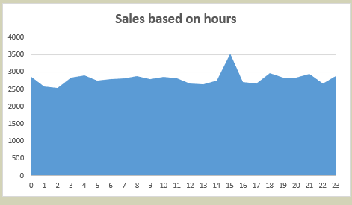

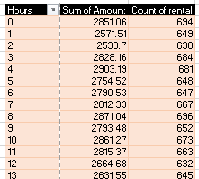

And mainly with regards to the cultural or demographic factors that influence customer preferences in different locations, it ha a greater impact and regional development on stores with a huge success and profit rate. With having the customer country as a demographic data we can come to a conclusion with respects to the rental data of each and every customers a shown below:

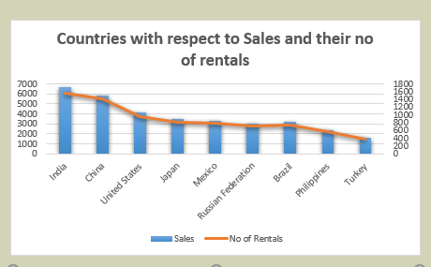

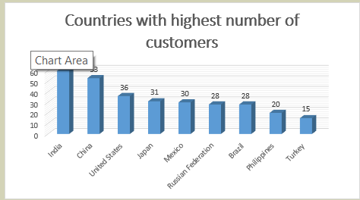

And finally with regards to the availability of films in different languages significantly impacts customer satisfaction by fostering inclusivity and accessibility. A diverse selection ensures that a wider range of customers can enjoy movies in their preferred language, meeting their cultural and linguistic expectations. This, in turn, leads to enhanced customer experiences and greater satisfaction. Customers appreciate a service that caters to their language preferences, making them more likely to stay engaged and become loyal patrons. Moreover, it expands the service's appeal globally, attracting a broader audience and positively influencing word-of-mouth recommendations, ultimately contributing to a thriving movie rental platform.

But with the given dataset and information there is no other languages except English which is very prominent and most known language and we can come to final part which language, region that supports and demographic area are the basic main traits for a successful store to rent movies.

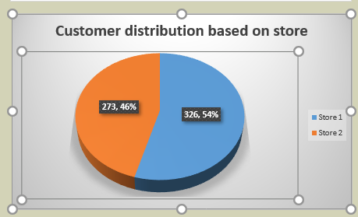

**Conclusion:**

As a conclusion, understanding and catering to customer preferences, demographics, and behaviors are paramount in building a successful movie rental business. Tailoring movie selections, pricing strategies, and marketing efforts based on these insights enhances customer satisfaction, fosters loyalty, and boosts revenue as told using the above analysis. The strategic placement of stores and ensuring a diverse inventory further solidifies customer loyalty. Moreover, the availability of films in various languages and their impact on accessibility and inclusivity play a significant role in satisfying a diverse customer base. Ultimately, a customer-centric approach and informed decision-making are the cornerstones for a prosperous movie rental venture.